Playdough Recipe
1 mug of salt
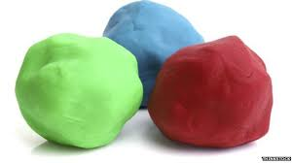
2 mugs of plain flour
2 tablespoons of vegetable oil
2 mugs of boiling water
Food colouring

Put it all in a bowl and mix and then knead. Keep in an air tight container to use again.

