

Willow Nursery School Prospectus

3+ Main Nursery

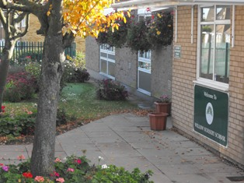

*“This is an outstanding school……children achieve outstandingly well in all areas of learning…..children benefit from exceptional teaching…behaviour is outstanding…the school has sustained the outstanding teaching and achievement of the previous inspections…all children make excellent progress from their starting points.” Ofsted 2012*

Contents

* Page 3 Welcome
* Page 4 Contact Details
* Pages 5-6 Our Vision
* Page 7 Our School
* Page 8 Organisation and staffing
* Pages 9-12 Staff
* Pages 13-18 Curriculum
* Page 19 Starting at Willow Nursery School
* Pages 20-22 Health and Safety Matters
* Page 23 Partnership with Parents
* Page 24 Supporting the School
* Page 25 Safeguarding
* Page 26 Clothing/Uniform
* Page 27 Milk and Fruit
* Page 27 Lunchtime
* Page 27 Library Books
* Page 28-29 Expectations for Behaviour
* Page 30 Meeting Children’s Needs
* Page 31 Transition to Primary School

Welcome

Welcome to Willow Nursery School, a long-established nursery in the residential area of Dunstable. It has an exceptional reputation for providing excellent care and education to children aged between 2 and 5 years old.

Willow Nursery School is one of Central Bedfordshire’s maintained nursery schools, all of whom are under the direction of their own head teacher. The qualified staff at Willow comprises of graduate teachers and trained teaching assistants.

Our aim is to provide a welcoming, friendly and secure setting where your child can thrive. We intend to help children gain the important skills they need for life. These skills include learning how to be independent, being kind and respectful of others and to develop qualities such as perseverance, confidence, enthusiasm and tolerance.

The children will learn through play and first-hand experience and be offered the opportunity to participate in a variety of experiences that will enhance their skills and knowledge.

We hope that this prospectus will provide you with the information you need to help you decide whether Willow Nursery School is the right environment for your child. We encourage you to ring and arrange a visit to come and see the high quality care and education we provide.

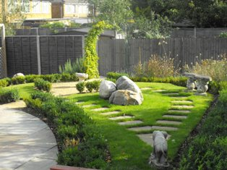

Contact Details

Head Teacher – Mrs Leigh Davies

Willow Nursery School  
Goldstone Crescent  
Dunstable  
Beds  
LU5 4QU  
Phone: 01582 662600

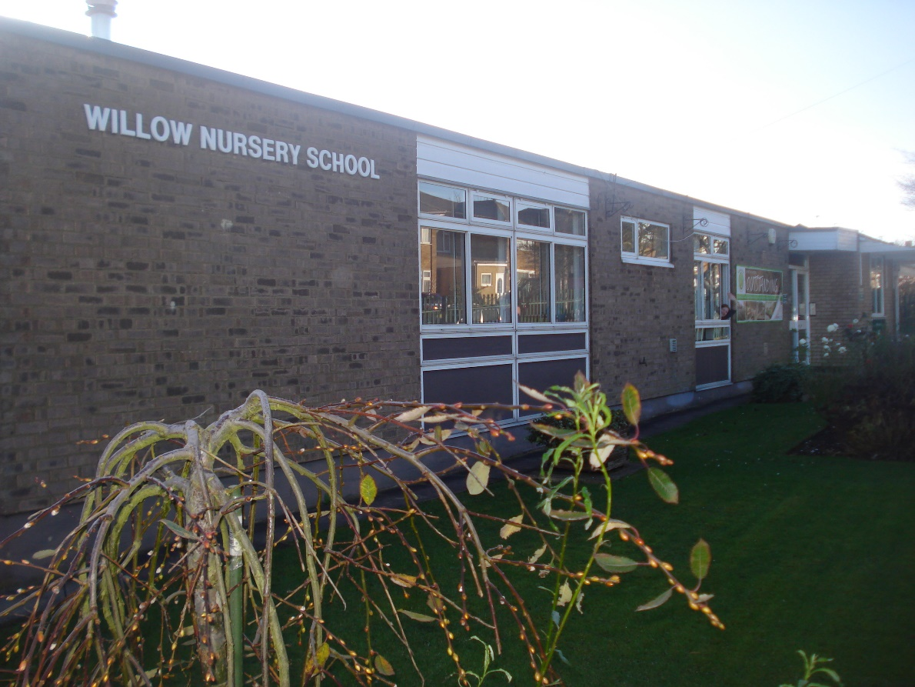

Our Vision

**For the children…….**

* To be welcomed into the school community
* To be valued as an individual
* To be offered the opportunity to participate in a variety of experiences that will enhance their skills and knowledge
* To be encouraged to be independent in their thinking and learning
* To learn through play and through first-hand experience
* To have access to a meaningful, focused, enjoyable curriculum
* To develop a sense of kindness and respectfulness
* To develop the qualities of confidence, enthusiasm and tolerance and perseverance
* To become prepared for the next stage of their education

**For the parents/carers……**

* To be provided with a welcoming environment
* To be valued as individuals
* To have a positive experience of their children’s first steps into the educational system
* To work in partnership with the school staff in a spirit of mutual respect, honesty and openness
* To be informed about the curriculum and experiences that are available in the Nursery
* To be aware of and share in the values of the school community

**For the staff……**

* To work within an atmosphere of mutual kindness, honesty and respect
* To work with a sense of commitment to the children, parents and staff team
* To have the opportunity to develop their own expertise, knowledge and skills

**For the governors……**

* To work in partnership with the staff
* To be involved in the life of the school
* To fulfil their roles and responsibilities with commitment and enthusiasm

Our School

In line with the criteria laid down in the admission policy by the Governing Body, children’s names can go on to the waiting list at any time. They will be offered a funded place in the term following their third birthday, subject to availability. We aim to give a minimum of three terms with us before a child transfers to primary school. Priority is given to a percentage of children who have particular needs. Children are offered 15 hours a week of government funded provision, which can be taken in a variety of ways. Extra sessions can be booked and paid for, at a current charge of £13.50 per half day session.

There are also places available for two year olds. The two year olds have their own room and outdoor area. The current charge is £15 for a half-day session (see separate prospectus).

We have room for 69 children in the main nursery per session. The school provides a curriculum in line with the DFE Foundation Stage curriculum.

Our morning session runs from 8.45am-11.45am.

Our afternoon session runs from 12.15pm-3.15pm

All day sessions run from 8.45am-2.50pm

If you accept an offer of a place at Willow Nursery School, you will be asked to fill in a “New starter” form**.** Your child is special and we need to know about anything at all that makes him/her extra special so that we can help and support him/her in school. We ask that you use the last page to tell us about your child- what they like/ do not like, what their favourite toys are etc. This is the beginnings of your child’s records which will detail his/her growing strengths and interests.

Organisation and Staffing

The main nursery consists of 4 classrooms and an outside area. The children can access the majority of these rooms and outdoors at all times. The main nursery is set out so that the activities on offer for the children cover all the areas of the Early Years Foundation Stage Curriculum.

On starting at nursery, each child is assigned a key worker. The role of the key worker is to ensure that your child is happy and feels safe and cared for in nursery. The key worker will build a relationship with you and your child and will be a point of contact. Your child’s key worker will write detailed observations of your child and share their record of progress with you at parent consultations.

The qualified staff at Willow work in pairs and rotate through the different areas of the nursery every two weeks. Each room focusses on different areas of the Foundation Stage Curriculum.

Room 1 is where the children learn about number, shape and space and about the world around them.

Room 2 focusses on expressive arts and design and this area is where the painting, box modelling and music area can be found (amongst other things!)

Room 3 is where the home corner can be found and most of the communication, language and literacy work happens in this room.

Our outdoor area is where the children can explore their larger physical skills.

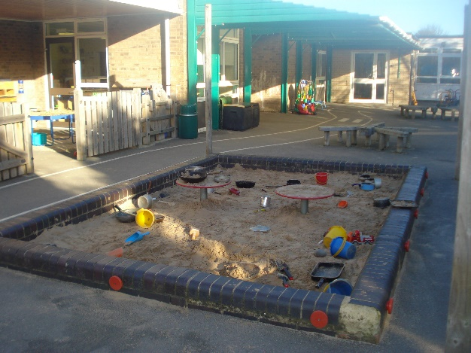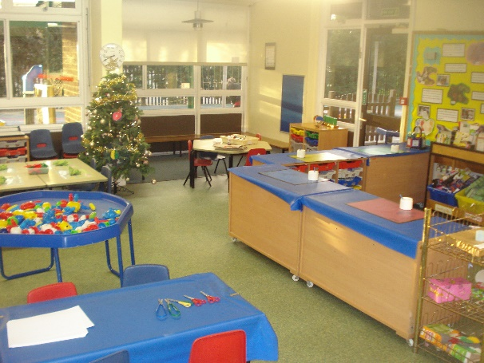

|  |  |  |
| --- | --- | --- |
| **Staff** | | |
| 036 | Leigh Davies | Head Teacher |
| 002 | Clair Howe | Deputy Head Teacher  Staff Governor |
| 050 | Cathy Shambrook | Finance Officer |
| 057 | Debbie Patterson | Senior Practitioner |
| 058 | Zoe Tyler | Catkins Class Room Leader |
| 001 | Lisa Brinkley | Catkins Class Room Leader |
| 037 | Kara Gaffney | Teaching Assistant |
|  |  |  |
| 059 | Ella McGrath | Teaching Assistant |
|  |  |  |
| 038 | Joanne McGowan | Teaching Assistant |
|  |  |  |
|  | Mr Michael Wilbourne | Site Agent |
|  |  |  |
| Governors | | |
|  | John Hassall  Leigh Davies  Clair Howe | Chair of Governors  Head Teacher  Staff Governor |
|  | Councillor Gloria Martin | Vice Chair of Governors |
|  | Sarah Flint | Parent Governor |
|  | Ann Hassall | Co-opted Governor |
|  | Emma Thake  Anne Cavendish | Parent Governor  Clerk |

Curriculum

Each child who comes into nursery has already started to learn through play at home and has learnt much through involvement with the family. As staff at Willow Nursery School, in partnership with parents, we continue to provide stimulating activities that will benefit the whole child and build on the foundations already laid. All activities, in each room and outside, are carefully planned to motivate and enrich the child’s learning. The planning is closely linked to the seven areas of learning as outlined in the DfE’s Statutory Framework for the Early Years Foundation Stage.

There are seven areas of learning and development that must shape educational programmes in early years settings. All areas of learning and development are important and inter-connected. Three areas are particularly crucial for igniting children’s curiosity and enthusiasm for learning, and for building their capacity to learn, form relationships and thrive. These three areas, the prime areas are:

* Communication and Language
* Physical Development
* Personal, Social and Emotional Development

We must also support children in four specific areas, through which the three prime areas are strengthened and applied. The specific areas are:

* Literacy
* Maths
* Understanding the World
* Expressive Arts and Design

Personal Social and Emotional Development.

This focuses on children learning how to work, play, co-operate with others and function in a group beyond the family. It covers the development of respect for others, personal values and attitudes and a positive disposition towards learning.

*Some of the experiences we provide to promote this:-*

* *Give children the opportunity to make choices and express preferences.*
* *Encourage children to take turns and share both equipment and adults’ time.*
* *Help children to develop persistence.*
* *Enable children to learn about special times and celebrations*.
* *Understanding and following the school’s rules*

Physical Development

This focuses on children’s developing physical control, mobility, awareness of space and manipulative skills in indoor and outdoor environments. It also includes the developing awareness of self-care and the factors that contribute towards good health.

*Some of the experiences we provide to promote this:-*

* *Provide children with the opportunity to use pencils, paint brushes, scissors, knives etc.*
* *Enable the children to use the bikes, climbing apparatus, balls- large and small etc.*
* *Learning the importance of physical exercise and a good diet.*
* *Managing own hygiene and personal needs.*

Communication and Language

This focuses on important aspects of language development and provides the foundation for literacy. It includes the skills of listening and attention, understanding and speaking. Children need to be competent in spoken language as soon as possible by making use of their developing skills in talking and listening. It is this that will provide the foundation for the development of literacy skills.

*Some of the experiences we provide to promote this:-*

* *Encourage children to respond to instructions.*
* *Give children the time to ask questions.*
* *Get children to listen to and respond to others.*
* *Listening to stories.*
* *Following instructions.*
* *Connecting ideas or events*

Literacy

This focuses on the beginnings of reading and writing.

*Some of the experiences we provide to promote this:*

* *Provide opportunities for children to choose books and give reasons for their choices.*
* *Help children to recognise their own names when in the written form.*
* *Promote the use of writing materials.*
* *Learning letter sounds and names*
* *Learning how to use and enjoy books and stories.*

Mathematical Development

This focuses on important aspects of mathematical understanding and provides the foundation for numeracy. Through practical activities the focus is on developing an understanding of simple mathematical language and ideas – counting, shape, etc.

*Some of the experiences we provide to promote this:-*

* *Encourage children to play matching and sorting games.*
* *Provide opportunities for children begin to count objects – around them inside/outside.*
* *Get the children to say / sing number rhymes and songs.*
* *Enable children to use 2D and 3D shapes to make pictures and models.*

Understanding the World

This focuses on children’s developing knowledge and understanding of the environment, other people and features of the natural and made world. It provides a practical foundation for historical, geographical, scientific and technological learning.

*Some of the experiences we provide to promote this:-*

* *Provide suitable computers and programmes for the children to use- with support if necessary.*
* *Enable the children to explore magnets, torches, programmable toys etc.*
* *Encourage the children to grow seeds, bulbs etc, care for them and watch how they grow.*
* *Give the children the opportunity to make maps –imaginary or real.*
* *Set up a variety of cookery activities for the children to experience.*
* *Give the children the time and opportunity to explore the outside environment- looking for mini-beasts, watching for the seasonal changes etc*.

Expressive Arts and Design.

# This focuses on the development of children’s imagination and ability to communicate and to express ideas and feelings in creative ways.

*Some of the experiences we provide to promote this:-*

* *Encourage the children to sing, make music and use musical instruments.*
* *Enable the children to get involved in role play.*
* *Provide the opportunities for children to use a whole range of painting techniques.*
* *Give children the chance to ‘have a go’ at a wide range of creative activities – collage, drawing, constructing- including the ‘self-selection’ of resources from a wide selection.*

As the Early Years Foundation Stage covers the period from birth until after the child’s fifth birthday, we aim to work in partnership with our receiving primary schools to implement that part of the curriculum that is relevant to our age-range of children.

Starting at Willow Nursery School

Before starting at Willow Nursery School, you and your child will be invited to a visit session which will give you the chance to meet your child’s keyworker, meet the staff and explore the nursery.

On your child’s first day at nursery, a member of staff will show your child where their coat peg is, their name card and their work folder. These all have a picture on that belongs to your child. Every session that your child is in, they will be encouraged to post their name card in the allocated box. With your help he/she will quickly learn to find his/her own things. This helps your child to feel he/she belongs to the group and this is very important.

Feel free to look around the school at the kind of things your child will be doing during the session and later you will be able to talk about them.

Come along, on the agreed starting date, with your child into their home base. You are, on the first day, welcome to stay for the session but if you would prefer, you are welcome to leave your child. We will work with you to make the transition to Nursery as smooth as possible for you and your child. Staff are experienced in judging the time it may take for a child to settle but recognise the expert knowledge parents have of their child. Together it can be agreed how slowly or quickly settling in shall be.

We do ask that parents bring in a labelled bag of clothes for their child which includes baby wipes and plastic bag. This is in case of any toileting accidents or getting wet or dirty during their play.

Health and Safety Matters

## Illness

It would be helpful if you would tell us about any childhood illnesses, allergies or health problems, and keep us updated during the course of any treatment, so that we can re-assure your child if he/she is unsure of the situation.

## Medicine in School

If your child needs to take any medicine during school time, please inform your child’s keyworker. This includes all children for whom an inhaler is prescribed. Any medicines must be clearly marked with your child’s name and the appropriate dose, and should be handed to a trained member of staff for storage, either in the staff room or in the fridge, as appropriate. You will need to sign the appropriate indemnity form, which is available from the classroom staff.

## Absence

If your child is going to be away, for any reason (medical appointments, holidays etc.), please let us know, preferably in writing. If your child is away because of illness, please phone the school before 9 am. If he/she has diarrhoea and/or sickness, please keep him/her at home until he/she has had no recurrence for forty eight hours, to prevent the spread of infection.

## Accidents

Children occasionally have minor accidents at school – please could you tell us if your child is allergic to sticking plaster or anything else. If he/she does have an accident we will tell whoever comes to collect him/her what has happened and what treatment has been given and/or put a note in their folder. The children are given a sticky badge to wear to remind them there is a note in their folder. In the event of anything more serious happening, or if your child becomes unwell, we will need to contact someone from home. Sometimes parents are out, even if they are normally at home, so we ask for an emergency number for each child – parent’s work number, grandparent’s or neighbour’s number etc.

## Toileting

Our expectation is that the children will be well on the way to being toilet trained. Whilst we encourage children to be sensible, independent and responsible for their own bathroom hygiene, we deal sympathetically with the occasional “slip”. For this reason we ask that you put a spare set of clothes on your child’s coat-peg, in case they need to change their clothes during the session. We would also ask that you send your child to school in clothes that are easy for him/her to deal with in the toilet.

If your child is not toilet trained before they start at Willow, please let your child’s keyworker know in advance, so that we can put together a plan that will support your child to achieve continence.

## Safety

Now to more general matters of safety.

1. Please ensure that you shut behind you whichever school gate you use. Please close **both bolts** on the front gate
2. Please bring your child into the classroom and make sure that the staff always knows that he/she has arrived, even if you just wave in passing, and especially if you are at all late.
3. If, for any reason, you are late getting to school at the start of a session it is essential you let the office manager know your child is in school. Please also sign in the “late book”.
4. When the front door is locked please ring the bell to the left of the door.
5. Please let us know is anyone different is collecting your child and remember children can only be collected by a responsible adult – i.e. over 16 years of age.
6. Please think about the safety of your child’s clothing. We do not like children to use our climbing frames and wheeled toys with trailing scarves, mittens/gloves on strings or ties on the bottom of their coats which can get caught. If children are wearing these things we encourage them to tuck scarves and gloves inside coats and have ties done up, and even then some children occasionally get caught. If your child’s coat has a drawstring tie at the bottom, please consider removing it if it is not used, as these do present particular problems.

Partnership with Parents

At Willow Nursery School we like to have a working partnership with parents/carers and feel that many would like to become involved in their child’s education. To keep parents informed we issue Weekly Newsletters via the children’s folders which are kept in their home bases. Please look there daily.

Each term there will be opportunities for parents to talk to the keyworker and discuss their child’s progress. However, we hope that parents will approach us if they have a particular query and not wait for consultation times. The staff look and are extremely busy but will always find time to discuss urgent matters. If you do ever have cause for complaint please speak to your child’s keyworker first. Anything unresolved can easily be discussed further with the headteacher. Parents, naturally, have recourse to contact any of the governors.

Our partnership with parents/carers includes our desire to collaborate with you in your child’s education. Experiences at home are highly significant and can enhance what is happening in school. You can give support by discussing the various themes and activities with your child, e.g. number spotting, borrowing library books, valuing pictures/models etc. Parents/carers who become interested in a term’s topic/theme will soon convey to their child that involvement can really be enjoyable. If this atmosphere is created, then often there is an inbuilt motivation and the child will progress.

This school believes that play linked with learning must be enjoyable and also taken seriously, so talking about, sharing with and following up investigations with a child can develop his/her understanding and encourage ongoing investigations. Similarly activities/ideas/occurrences that have happened at home can be shared / brought to school.

Supporting the School

At Willow Nursery School we like to work in partnership with all parents/carers and hope you will support what is happening in school by discussing the various themes and activities with the children. Some suggestions for ways of supporting the school activities are outlined below.

# At Home

Saving boxes etc. also paper, scrap materials etc,

At School (on an occasional or a regular basis)

Sharing activities with the children, e.g, cookery, creative work, board games etc.

To list all our requirements would be lengthy, so our Weekly Newsletter is an important feature of the school and we urge you to read it regularly for up to date news. From time to time we will request items that we need. For example we will often ask for donations of boxes of tissues throughout the winter months. Also we sometimes put an urgent “S.O.S” notice on the front door and your responses to these are always much appreciated. For example, for some craft activities we might need lots of empty toilet roll tubes.

Safeguarding

It is important that you know your child is happy in school. If we have concerns we will talk to you. Please let us know if you have any concerns or if there are changes at home, for instance the loss of a pet, changes in your child’s behaviour or if they seem tired or upset. Occasionally the school may have more serious concerns and would need, by law, to follow the Child Protection procedures. We would discuss the concerns with you first, where possible. The school has a legal duty to follow these procedures.

The school’s designated safeguarding officers are:



Mrs Leigh Davies Miss Clair Howe

They can be contacted at the school on 01582 662600 or via email [willow@cbc.sch.beds.uk](mailto:willow@cbc.sch.beds.uk)

***It is everyone’s responsibility to keep our children safe and free from harm.***

**PLEASE DO NOT USE MOBILE PHONES ON THE NURSERY SCHOOL SITE**

Clothing/Uniform

We encourage the children to be as independent as possible, so clothes need to be easy for your child to get on and off. Jeans or trousers with tight buttons, trainers/boots with long laces etc. can present problems and mittens are easier than gloves. Many of the activities here are wet or messy, so it is best for your child not to wear “good” clothes.

Shoes should be comfortable and suitable for indoor or outside play, (e.g. running and climbing). If wellingtons are worn, a pair of other shoes to change into may be appropriate. It would help if you would put your child’s name inside shoes and boots, as children often take them off when playing. Similarly, any other items of clothing that your child may take off should be marked.

The children have the opportunity to play outside every day and, as it can be rather cold after a time, they will nearly always need a coat or cardigan.

At Willow Nursery School, we have no set school uniform. We do have sweatshirts, t shirts and polo shirts with the school logo, in a variety of colours, which can be ordered online from school trends.

[www.stparent.co.uk](http://www.stparent.co.uk/)

For any queries relating to your order, please contact school trends:

Email:willownursery@schooltrends.co.uk

Telephone:  0114251 2501

Milk and Fruit

Children under the age of 5 are entitled to free milk every day. This is usually provided in 1/3 pint cartons with a straw. We ask for donations of fruit and vegetables from parents for the staff to cut up and share at snack times.

Lunchtime

Children that are staying for a whole day session will need a packed lunch. The lunch needs to be in a labelled bag or box. We encourage healthy eating and expect a small sandwich, raw vegetables, a portion of cheese, a yogurt, some fruit and a drink. Warm food can be sent in for your child in appropriate Tupperware.

Library Books

The school has a library system in which children are encouraged to take 1 or 2 books to share at home. These books need to be signed in and out using the library folder which can be found in the entrance lobby.

Expectation for Children’s Behaviour

At Willow Nursery School, as part of their personal, social and emotional development, we aim to promote in children a perception of what is right and wrong and why, and for them to behave appropriately. Children are actively encouraged to take turns and to share fairly. They should also develop an understanding of the need for rules and the acceptance of those rules. We encourage respect for others, their property, the environment and all living things.

At Willow Nursery School any incident of bullying (physical or verbal) is considered a serious matter. The member of staff seeing or hearing an incident should be the person to deal with that incident, as well as insuring the child’s keyworker is informed. Any support and involvement of the head teacher and discussions with the parents should be agreed and also recorded.

At Willow Nursery School we have straight forward expectations for children’s behaviour, which are listed below:-

1. Always try to be thoughtful and kind towards everyone.
2. Always remember that the adults are here to help you.
3. Always go to your home base when you get here.
4. Always go back to your home base before you go home.
5. Always stay inside your school unless a grownup says you may go out.
6. Always walk when you are inside your school.
7. Always keep your school tidy and do not leave a mess behind you.
8. Always be still when you are eating and drinking.

To support children in relating to these expectations it is the role of the staff to try and pre-empt any difficulties e.g. by use of a range of organisational strategies, distraction.

To further support children the basic pattern will be that a child not conforming will be asked to do so and given an explanation of the reason why.

A child still not conforming will then be told to do so and given a further explanation of why.

A child still not conforming must then be subject to some sort of sanction, (e.g. removal from an activity, sent inside,) with a further explanation of why. This must be followed by an opportunity to try and make amends.

The final sanction is to involve the head teacher in helping enable the child to accept the school’s expectations. If the parents have not been involved before this point they will now be informed of the school’s concern in order to facilitate a partnership approach in supporting the child.

Meeting Children’s Needs

We are aware of children’s individual needs and would ask you to work alongside us to enhance the development of the whole child. Children’s varying needs are best met in structured social settings, giving a degree of individual attention in a range of groups, and where a team of qualified staff celebrate successes as part of their positive view of children. We set high expectations for children because we believe learning should be challenging, yet fun.

Our planning makes available a wide variety of activities for both child initiated, self-directed play and adult focused situations. Your child, when he/she starts school, will be confronted with a wide variety of “choices”. These activities/choices can include role-play, cookery, table games, water/sand/clay, painting, drawing, matching/sequencing, puzzles, construction with large and small equipment and woodwork. There are different experiences in each room and so please look round the school, inside and out, at the things your child will be doing and then you will be able to discuss and encourage him/her when he/she is at home.

There is always opportunity for each child to work alone, to be working alongside a group or to be totally involved within a group and a child can benefit and increase their learning from each type of involvement.

Special Educational Needs and Disability

Our provision for children with special educational needs and disability (SEND) is guided by our objectives for all children in the school. It is a general principle of the school’s team approach that all staff have an active role in the education of every pupil. The school has a named special educational needs co-ordinator (Miss Howe) and, together with the Local Authority under the SEND Code of Practice, the needs of all children with SEND are identified, assessed and reviewed.

The school also aims to meet the needs of the more able pupil through a parallel process of identification and provision. We encourage children to develop their ‘talents’, whichever direction they lead them.

Transition to Primary School

We aim to prepare the children for transition to primary school and we work alongside all of the schools that we feed to. We welcome visits from teachers and we complete the necessary paperwork that the Local Authority requires us to for the succeeding schools. We encourage visits to new schools and, through discussion and activities, hope to prepare the children for the next stage in their learning.