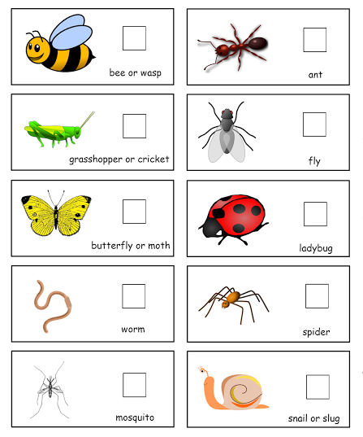
Bug Hunt
Can you find these living things in your garden?

